/\*

C code of two 2 by 2 matrix multiplication using Strassen's algorithm

\*/

#include<stdio.h>

int main(){

int a[2][2], b[2][2], c[2][2], i, j;

int m1, m2, m3, m4 , m5, m6, m7;

printf("Enter the 4 elements of first matrix: ");

for(i = 0;i < 2; i++)

for(j = 0;j < 2; j++)

scanf("%d", &a[i][j]);

printf("Enter the 4 elements of second matrix: ");

for(i = 0; i < 2; i++)

for(j = 0;j < 2; j++)

scanf("%d", &b[i][j]);

printf("\nThe first matrix is\n");

for(i = 0; i < 2; i++){

printf("\n");

for(j = 0; j < 2; j++)

printf("%d\t", a[i][j]);

}

printf("\nThe second matrix is\n");

for(i = 0;i < 2; i++){

printf("\n");

for(j = 0;j < 2; j++)

printf("%d\t", b[i][j]);

}

m1= (a[0][0] + a[1][1]) \* (b[0][0] + b[1][1]);

m2= (a[1][0] + a[1][1]) \* b[0][0];

m3= a[0][0] \* (b[0][1] - b[1][1]);

m4= a[1][1] \* (b[1][0] - b[0][0]);

m5= (a[0][0] + a[0][1]) \* b[1][1];

m6= (a[1][0] - a[0][0]) \* (b[0][0]+b[0][1]);

m7= (a[0][1] - a[1][1]) \* (b[1][0]+b[1][1]);

c[0][0] = m1 + m4- m5 + m7;

c[0][1] = m3 + m5;

c[1][0] = m2 + m4;

c[1][1] = m1 - m2 + m3 + m6;

printf("\nAfter multiplication using Strassen's algorithm \n");

for(i = 0; i < 2 ; i++){

printf("\n");

for(j = 0;j < 2; j++)

printf("%d\t", c[i][j]);

}

return 0;

}

Apply it on 4\*4 matrix

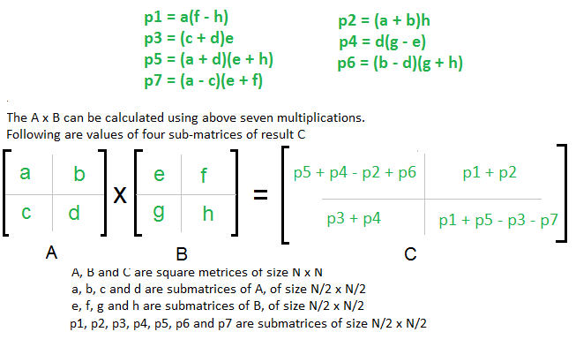

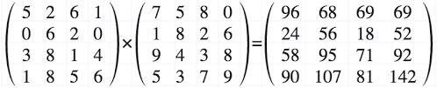

m1= (a[0][0] + a[1][1]) \*( (b[0][2] + b[2][2]);

m2= (a[1][0] + a[1][1]) \* b[0][0];

m3= a[0][0] \* (b[0][1] - b[1][1]);

m4= a[1][1] \* (b[1][0] - b[0][0]);

m5= (a[0][0] + a[0][1]) \* b[1][1];

m6= (a[1][0] - a[0][0]) \* (b[0][0]+b[0][1]);

m7= (a[0][1] - a[1][1]) \* (b[1][0]+b[1][1]);

c[0][0] = m1 + m4- m5 + m7;

c[0][1] = m3 + m5;

c[1][0] = m2 + m4;

c[1][1] = m1 - m2 + m3 + m6;